We have different types of Networks available

Standard Network

$$input layer: No need of provide weights, No need of provide bias$$

$Number of neurons=Number of input features$

$$Hidden layer-1$$

$$Hidden layer-2$$

$$Hidden layer-3 ====More hidden layers , model will be complex$$

$$between Input layer and Hidden layer we have weights, and hidden layer neurons has bias$$

$$output layer:$$

$we have weights between hidden layer to output layer$

$$how many neurons we need to choose in output layers$$

$Bi classification: One neuron$

$$Multi classification: Number of Neurons=Number of lables$$

$$These output Neurons has Bias also$$

$$Hidden layer is used to understand more patterns$$

$$One nuron layer information pass through another neuron layer,$$

$$It is a conti process to understand more patterns$$

$$Hidden layers also refer to the model complexity like in Decision tree depth,$$

$$like in linear regression adding more features$$

$$Hidden layers you need to compare with bias-variance trade off$$

$$More hidden layer====overfit$$

$$less hidden layers=====undr fit$$

$$How many hidden layers we need to choose?How mant neurons in a hidden layer choose$$

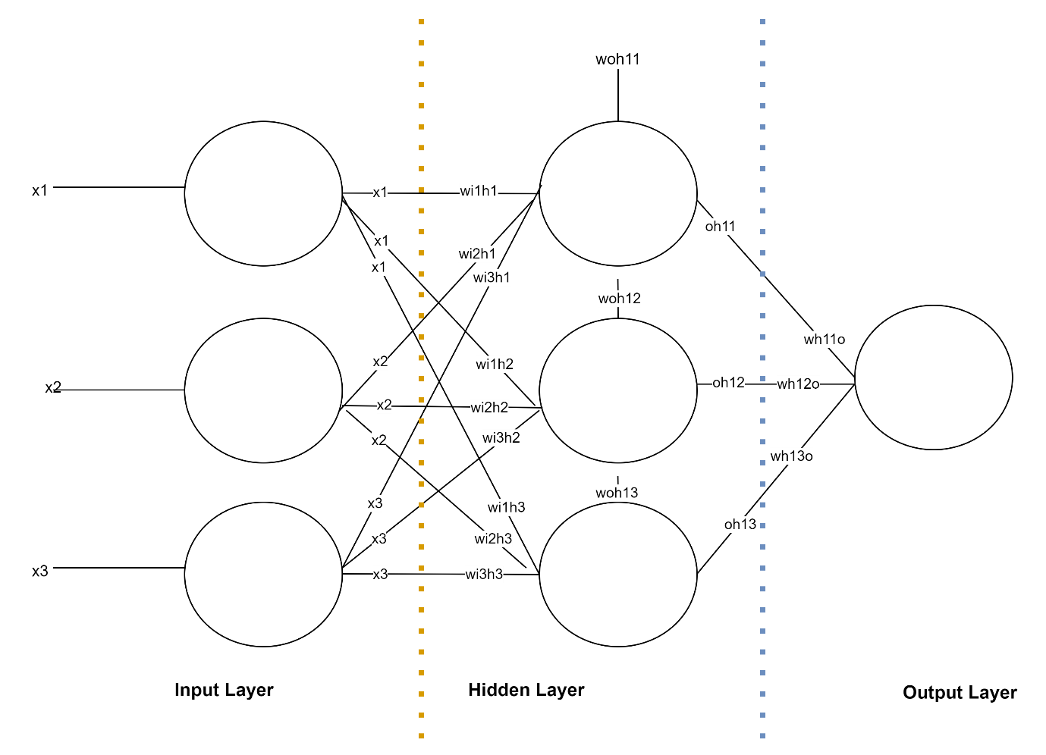

Inputs= 10 Neurons

Hidden layer =10 Neurons

Output layer=10 Neurons

How many total parameters to be trained?

10*10+10 and 10*10+10 total 110+110= 220

|  |  |
| --- | --- |
| Layer | Params |
| Input layer | 0 |
| Hidden layer | 10*10+10=110 |
| Output layer | 10*10+10=110 |
| Total | 220 |

Inputs= 28 Neurons

Hidden layer =100 Neurons

Output layer=10 Neurons

How many total parameters to be trained?

|  |  |
| --- | --- |
| Layer | Params |
| Input layer | 0 |
| Hidden layer | 28*100+100=2900 |
| Output layer | 100*10+10=1010 |
| Total | 3910 |

Input = 28x28 Image ========== Number of neuron 28x28=784 pixels

Hidden layer= 128

Hidden layer

Output layer =10

|  |  |
| --- | --- |
| Layer | Params |
| Input layer | 0 |
| Hidden layer | 784*128+128=100480 |
| Output layer | 128*10+10=1290 |
| Total | 101770 |

Every one able to write the weights and Bias

Math equations

Important questions

1. How to choose weights
2. How to choose activation function
3. How to choose hidden layers

Model will be overfit

How to avoid overfit

1. How to choose hidden layer Neurons

More parameters to train

More time is required

How can I optimise that

1. How to Choose weights:

ANN: Artificial Neural Network : Perceptron

DNN: Deep neural Network : Multi layer Perceptron

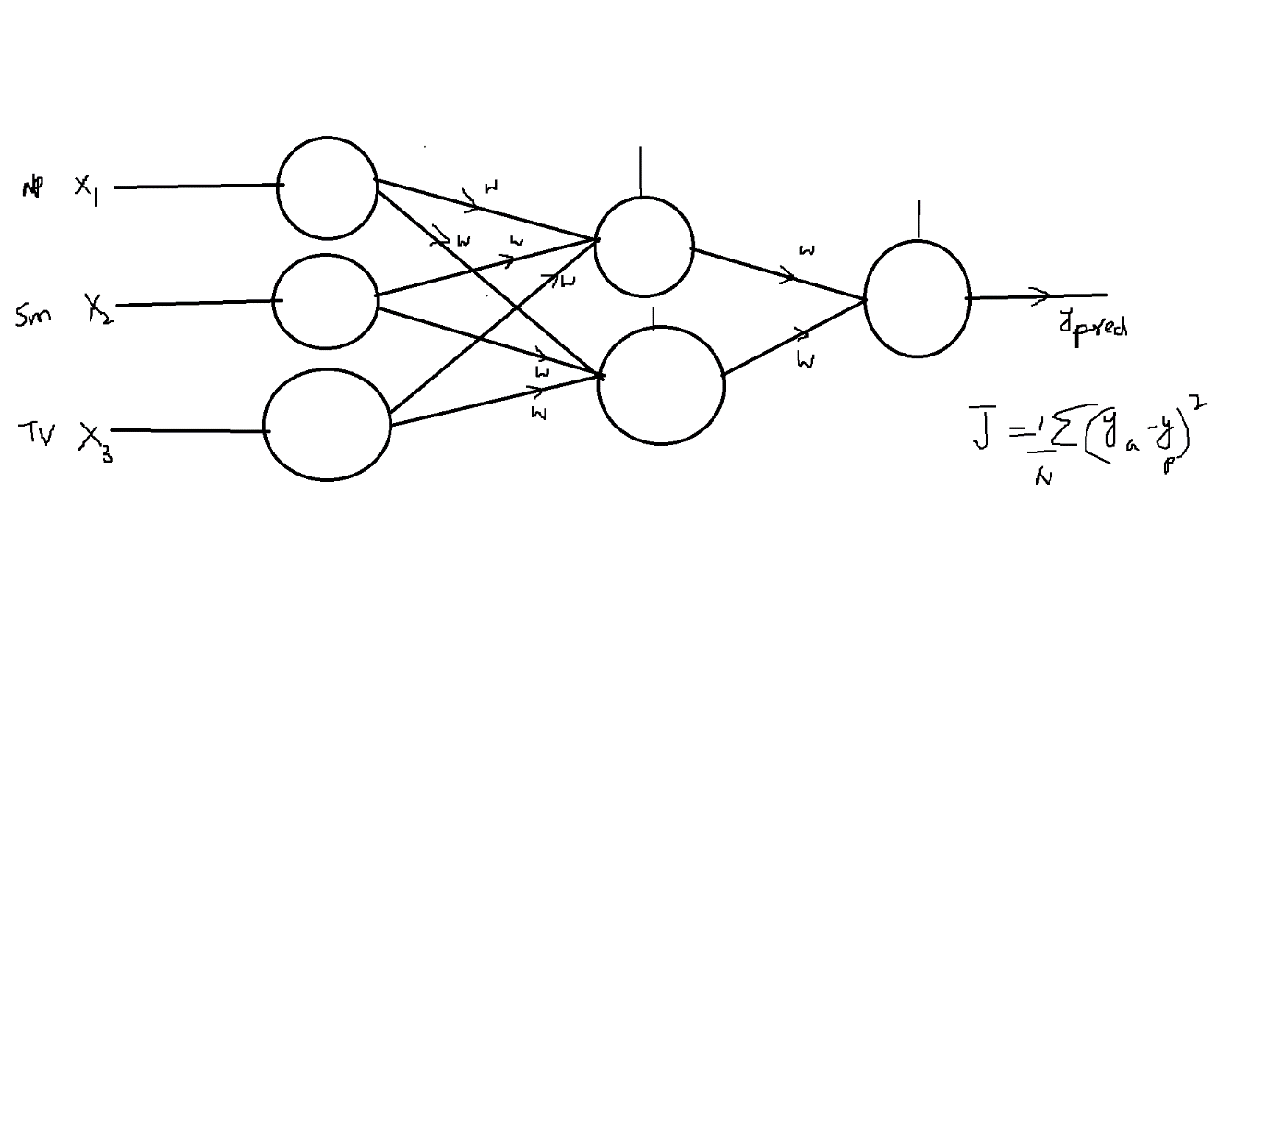

$$Goal is Minimise the error to find suitable weights$$

$$Intially will provide weights randomly$$

$$Then will calculate the error or loss or cost=J$$

$$We will think about who are responsible for getting maximum error?$$

$$Every layer weights are responsible to get error either low or max$$

$$Forward Prpogation vs Backward prpogation$$

$$Forward Prpogation :$$

$$Will intilaise random weights,$$

$$input values pass through weights,$$

$$And neuron sum of all the inputs with weights$$

$$and apply the activations$$

$$and pass through another layer$$

$$Backward Prpogation$$

$$Now will check the error,$$

$$To reduce the error we go back and update the weights$$

$$This is iterative process Forward and Backward$$

$$Forward Prpogation+Backward prpogation=Epoch$$

$$10 Epoch: 10 times we are iterating$$

$$Forward=Activation\left(Inputs*Weights\right)=Output$$

$$Loss or cost , you want to minimise that$$

$$Back ward : Update the weights$$

$$How to update the weights:$$

$$In Linear regression : OLS method$$

$$In Neural network : Gradient descent$$

$$Gradient means= slope$$

$$y_{2}-y_{1}=Δy=dy$$

$$x_{2}-x_{1}=Δx=dx$$

$$m=slope=\frac{\left(y_{2}-y_{1}\right)}{x_{2}-x_{1}}=\frac{Δy}{Δx}=\frac{dy}{dx}=tan(theta)$$

$$I want to find minmum value y=x^{2}$$

$$case-1:$$

$$at x=4 I assume we have minmum point for y=x^{2}$$

$$if you want get minmum, there is no slope at minmum values$$

$$\frac{dy}{dx}=2*x$$

$$Now substitute x=4 at \frac{dy}{dx}=2*4=8$$

$$Case-2:$$

$$If slope is postive= -$$

$$If slope is postive= -ve$$

$$x_{new}=x_{old}-\left(\frac{dy}{dx}\right)at x=x_{old}$$

$$x_{new}=4-8=-4$$

$$\frac{dy}{dx}=2*x$$

$$Now substitute x=-4 at \frac{dy}{dx}=2*-4=-8$$

$$Case-3:$$

$$If slope is postive= -$$

$$If slope is postive= -ve$$

$$x_{new}=x_{old}+\left(\frac{dy}{dx}\right)at x=x_{old}$$

$$x_{new}=x_{old}-0.2*\left(\frac{dy}{dx}\right)at x=x_{old}$$

$$x_{new}=4-0.2*2*4=4-1.6=2.4$$

$$x_{new}=x_{old}-0.2*2x$$

$$x_{new}=2.4-0.2*2*2.4=1.44$$

$$x_{new}=x_{old}-0.2*2x$$

$$x_{new}=1.44-0.2*2*1.44=0.86$$

$$x_{new}=x_{old}-0$$

$$x_{new}=x_{old}-α*{\left(\frac{dy}{dx}\right)}_{x=x_{old}}$$

$$α=learning rate=\left(0,1\right) 0.2 0.1 0.02$$

$$w_{new}=w_{old}-α*{\left(\frac{dJ}{dw}\right)}_{w=w_{old}} (Graident descent )$$

$$w_{old}=random values$$

$$iterate above equation till you get differentiation cost function=0$$

$$w_{new}=w_{old} at some point weights are fixed , which means cost function=0$$

